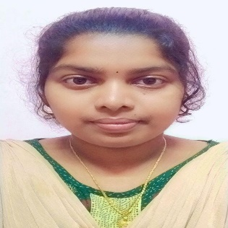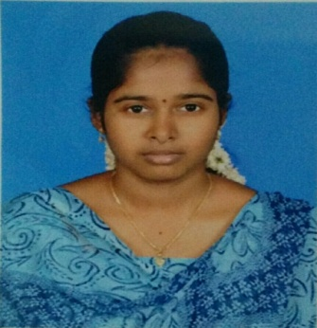

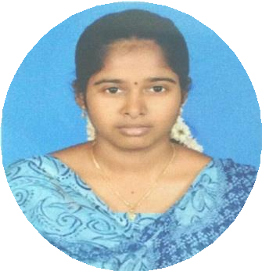

**OBJECTIVE**

**CONTACT ME**

To accelerate my place towards the growth of the organization by riding on my strength and to make innovations with my talented skills.

**JOTHIKA SANKAR**

**5a4525e9546ddca7e1fcbc85.pngloc1.png**00

* Block Chain
* Web Designing

**AREA OF INTEREST**

**E.Mail ID**

jothika.sankar25@gmail.com

**Phone**

+918122423940

Completed SENIOR GRADE in **TypeWriting English** at Government Technical Examination with **FIRST CLASS.**

**CERTIFICATION**

**Tools**

MS-Office.

**Language Known**

C/C++,HTML,CSS,JavaScript.

**SKILLS**

**2018-2019**

State Board

**SSLC – 69.4 Percentage**

S.D. Eaden Matriculation Hr. sec. school, Vadalur

**2019-2021**

State Board

**HSC – 76.34 Percentage**

S.D. Eaden Matriculation Hr. sec. school, Vadalur

**2021-2024**

Annamalai University

**Bachelor of Computer science - Pursuing**

Krishnasamy College of Science, Arts and Management for Women Annamalai University

**EDUCATION**

**Address**

8B,NagappaSamy Nagar,

GH BackSide,

Kurinjipadi(TK),

Vadalur(PO),

Cuddalore(DT),

Tamilnadu-607303.

Yours Faithfully,

(Jothika S)

I hereby declare that all statements made in this application are true and correct to the best of my knowledge.

Father’s Name : G.Sankar.

Mother’s Name:S.Muthulakshmi

Date Of Birth: 25/08/2003.

Gender : Female.

Nationality : Indian.

Martial Status: Unmarried.

Languages :Tamil,English.

Hobbies : Playing Tennis,Surfing Internet.

**PERSONAL DETAILS**

Date:

Place:

**DECLARATION**

Hardworking towards the achieving the Goal.

Intellectual thinking.

Flexibility in technical area.

Quick Learner and positive attitude.

**STRENGTHS**